Adrian Sanchez

English-11

Mr. Eynon

3 February 2016

American Ford GT V.S Italian Horse Ferrari

# Opinion-Article by Adrian Sanchez February 3, 2016

Ford GT, a 3.5-liter V-6 twin turbo Eco boost car that produces 600 hp and 550 pound feet or torque. But is that enough power to compete against the Italian horse Ferrari. The 2017 Ford GT is an anticipated car by millions of car enthusiast since the last version of GT which was made in 2006, which people loved. Ford states that in 24 hours La Mans, a racing event that truly shows the cars endurance in capability on the track, they will arrive and run laps around Ferrari and I feel they are ready to take on Ferrari because the 2006 GT did it and so will the 2017 GT.

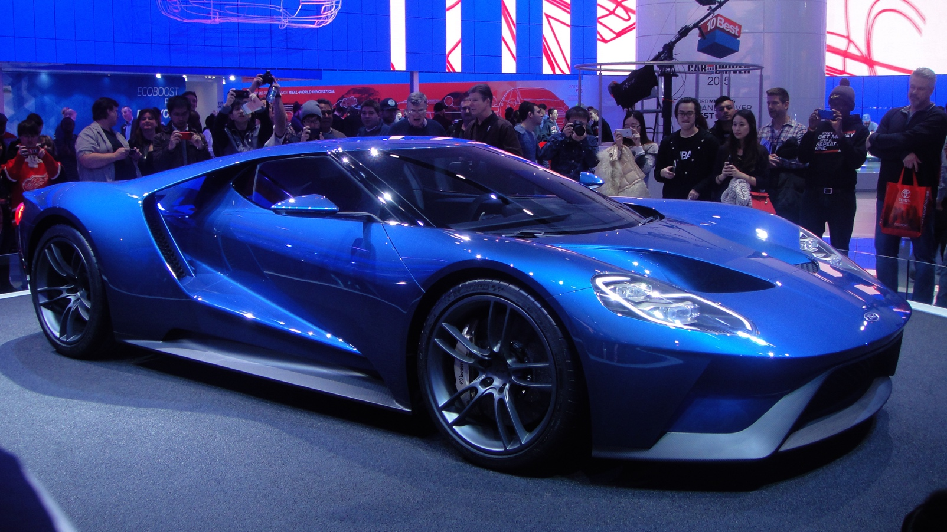

*The redesigned 2017 Ford Gt been displayed at the Detroit Auto Show*.

Fords feud with Ferrari started in 1963 Ford Motor company attempted buying Ferrari but Enzo refused to sell Ferrari to Ford. Ford knew they had to get back at Ferrari. Ferrari had won the 24 hours of le mans 4 years in a row.

Ford had tried to beat and compete against Ferrari in 24 Hours of Le Mans, but unfortunately they were not successful. After losing to Ferrari in Le Mans 4 years in a row ford decided to go back to the drawing board, and Carroll Shelby friend of Henry Ford and creator of Shelby automobiles stated “Next Year, Ferrari’s ass is mine”.

The year after that in 1966 ford introduced the first ever Ford GT-40 and came 1st place in 24 Hours Le Mans. They won first place in 67,68, and 69 in 24 Hours of Le mans. Now in 2016 Ford is planning to do the same take the Ford GT to Le mans and prove Ferrari theirs even better then when they were in 1966-1969.

**

*Ford that won the 1966 24 hours of Le Mans*

Although Fords amazing design of their new Ford GT theirs is some disagreements going on about the GT. When people heard the new Ford GT is going to have 3.5-liter twin turbo V-6 they sort of disagreed with the type of engine it was going to have etc. They believed they should stick with a V.8 supercharged engine due to Ford been an American car and company that is known to just produce V.8 engines.

Another thing that people are thinking is going to be a bad idea besides the engine type is going to have is that there are going to use an Eco-boost engine and Fords Eco-boost engines are not known to produce over 600hp.

All those allegations of the Ford GT were answered threw out several interviews made with some people who were in charge of the vehicle production.

An interview made by Auto week they talked with the director of Ford Performance Gerard Quinn. In that interview they ask him about how people say that the Ford GT should stick with its roots and use V.8 supercharger instead of the 3.5-liter twin turbo V6 Eco-Boost engine.

Quinn Director of Ford Performance states:

“A lot of people commented on that about the V.8 but when they actually saw the car reveled and then people have heard the car and it slowly starts to disapparate in their desire to have a V.8”

After that interview with Quinn we see that people really support the idea of Ford deciding to go with Twin Turbo V6 instead of sticking with their V.8. This also shows how ford is moving on to wanting to prove that American cars can compete in those events not only Ferrari, Lamborghini, Porsche etc. can compete in that super car level.

We can also see in this in this other interview with Mark Fields C.E.O and President of Ford Motor Company made by ABC news he was asked based on the cars Eco-Boost engine if it was efficient.

Mark then stated “To give them among the best or very best fuel economy”. He was stating that the Eco-Boost put in it is not only for performance is also to give the client the best fuel economy.

In this interview made by CNET they got to interview a member of the Ford Performance Team. They ask him about if they are ready for Le Mans against not only Ferrari but against all the other cars that are going to be arriving at Le Mans.

In another interview made by CNET they got a chance to talk to a member of the Ford Performance team member and ask him a couple of question regarding 24 hours Le Mans and if their ready.

They ask the member of Ford Performance if the Ford GT will be ready for the 24 hours Le Mans and he states “We won races like 12 Hours of Sebring and 24 Hours of Daytona” this shows how much faith they have on the Ford GT and he stated towards the end of the interview “You know a lot of people want to know what we are doing. We are going to Le Mans with one hell of a race car”.

All in all, is the Ford GT ready for this 24 hours of Le Mans, and ready to show up and run laps around Ferrari, yes they are, Ford will show up with an amazing car and it will win 24 hours of Le Mans.

Link to sources:

<https://www.youtube.com/watch?v=PG_GAAmfffg>

<http://www.cnet.com/roadshow/videos/the-2016-ford-gt-is-ready-to-take-on-ferrari/>

<https://www.youtube.com/watch?v=gBglySlygjs>